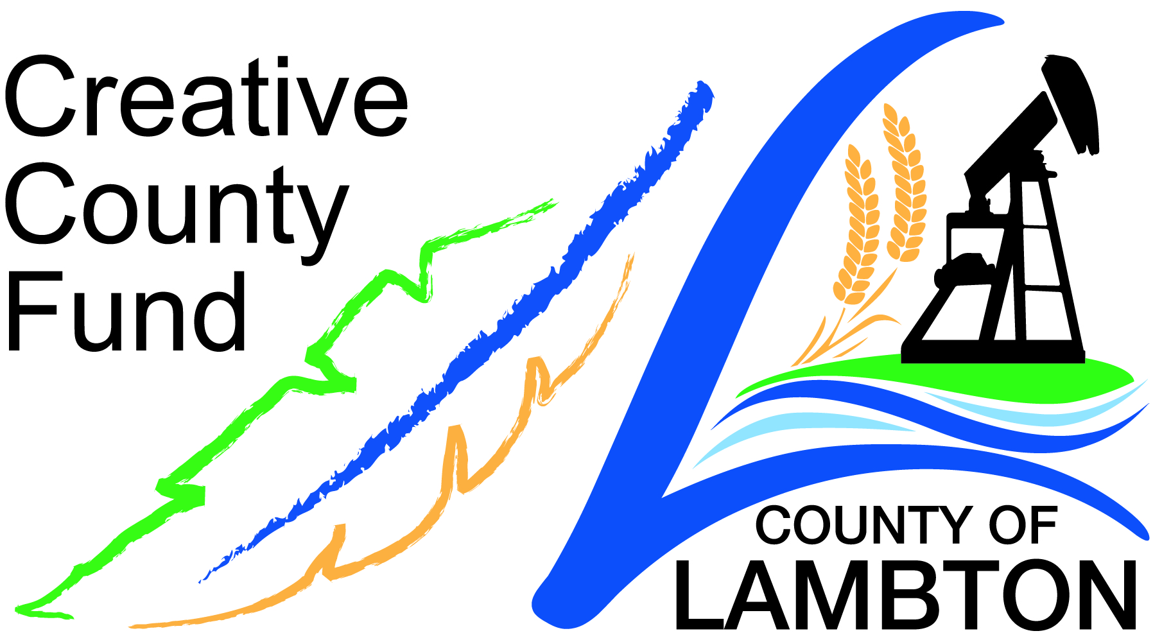
Lambton County Creative Fund

Post-Project Report

This information is required to summarize the performance of all projects that receive Creative County Funding. This report should be submitted within 3 months of your project completion. Acceptance of the completed Post-Project Report is required to release the final 25% payment of project funding.

Group Name:
Project Name:
Completed by:
Email:
Telephone:

Please refer to your original Application as a guide in completing this Report. A comment section appears at the bottom of the form. Please use it to explain how your actual project may have varied from your original project proposal.

1. CONTRIBUTION TO CULTURAL LIFE

What did you state on your initial application was the specific contribution to the cultural life of your community that would result from your project? How well did your project meet this goal?

2. PROJECT IMPACT

Again referring to your initial application, what impact were you hoping to achieve and how did you achieve it?

3. PROJECT OUTCOMES
Identify two Project Outcomes that resulted from your project. What were the measured results of these?

 | Outcome #1 | Outcome # 2
Targeted Outcome

Indicator of success and the tools used to measure this

Actual Results

4. PROJECT PARTICIPATION

What was the total number of people reached by your project, and in which Lambton communities?

5. PARTNERSHIPS

Describe any new partnerships that emerged from the project that will continue to network with your organization.

6. IMPORTANCE OF CREATIVE COUNTY FUNDING

How important was the Creative County grant to your project?

7. COMMUNITY IMPACT

How has the community benefited or been impacted by this project? How do you know that you were successful? Does your group envision a future repeat of the project, building on the foundation established by this project?

8. ACTUAL REVENUE AND EXPENDITURE SUMMARY

REVENUE SOURCES (identify)
Creative County Funding $
$
$
$
$
$

TOTAL REVENUE $

EXPENDITURES: (identify)
$
$
$
$
$
$

TOTAL EXPENDITURES $

SURPLUS OR DEFICIT $

Explanatory Notes for in-kind contributions:

9. GENERAL COMMENTS

Did the scope of your Project differ from what you had originally proposed? In what way?

Any comments about either your proposal experience or our application process are welcome.

Will you, or a resident or group who benefited from your project, agree to be interviewed in a Creative County video? If so, please provide the contact name and number.

PLEASE SUBMIT YOUR POST PROJECT REPORT TO:

Tara Pounds, Revenue Officer
The Corporation of the County of Lambton
789 Broadway Street, Box 3000
Wyoming, ON N0N 1T0
tara.pounds@county-lambton.on.ca

